**Observation**

Inspection was undertaken at the subject property in the presence of the building manager and maintenance manager to which the following damage was noted:

## Basement

1. It has been advised by the building manager that water ingress within the lowest basement level has been an ongoing problem for approximately three (3) years. **Images 2 – 3**
2. It has also been advised that water has been penetrating through the slab ground in the basement. **Image 4**
3. In facilitating the cause of the observed water ingress ***Figure 2*** has been provided below.

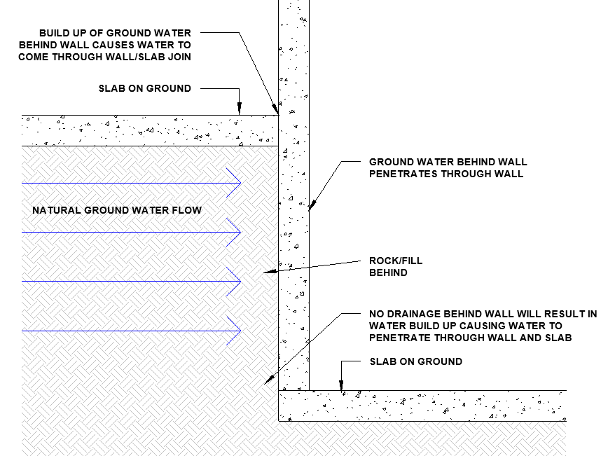

***Figure 2: Cause of Water Ingress within the Basement***

1. In our opinion, water ingress within the basement is a result of blocked subsoil drainage or the omission of subsoil drainage which has allowed water to build up against the concrete wall resulting in water to penetrate through the wall and slab on ground.
2. In our opinion, the water ingress is a result of inherent building defects and **is unrelated to the construction works on the neighbouring property or any other insurable event.**

## Southern Elevation

1. We noted the following damage to the render on the southern façade:

* Cracking and missing render at the slab edge and adjacent to slab edge. **Images 5 – 8**
* Vertical and horizontal cracking in render. **Images 9 – 10**
* Diagonal cracking propagating from the bottom of windows in the middle of the Southern façade. **Images 11 – 12**
* Cracking along vertical expansion joints. **Image 13 – 14**
* Missing render around pipe penetrations. **Images 15 – 16**
* Localised missing render on brickwork. **Image 17 – 18**
* Blistering and degradation of paint. **Images 19 – 20**

1. The majority of the damage to the render was at the slab edge which, in our opinion, is a result of long-term differential movement between the slab and wall resulting in cracking and delamination of render, in representing this effect ***Figure 3*** has been provided below.

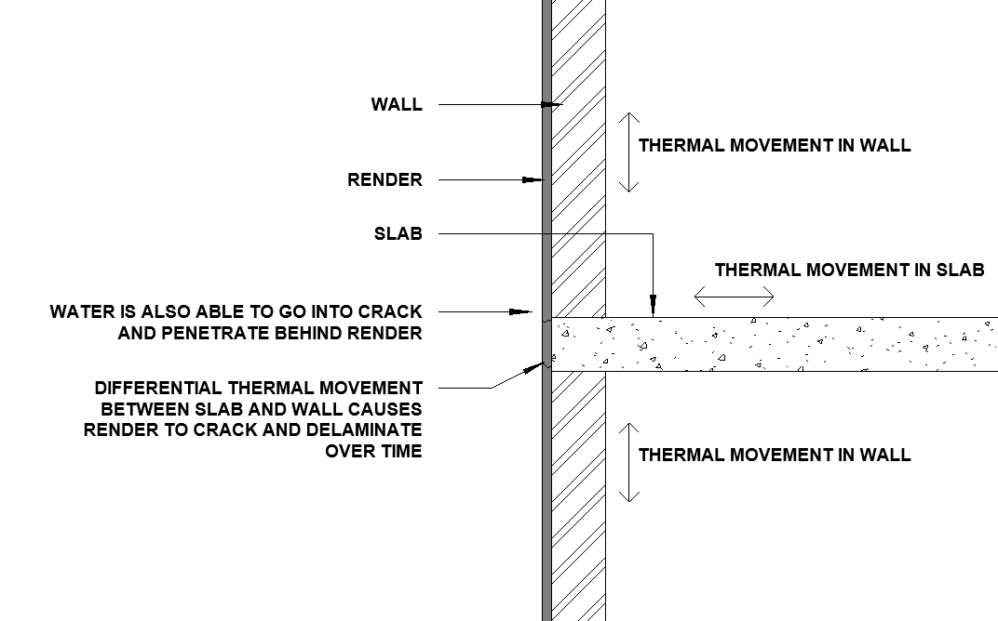

***Figure 3: Cracking in Render at Slab Edge Due to Differential Movement***

1. The observed vertical and horizontal cracking in render, in our opinion, is a result of thermal movement and shrinkage due to insufficient number and spacing of expansion joints in the render.
2. In our opinion, the observed diagonal cracking below windows is a result of long-term differential settlement within the subject building occurring over an extended period of time in years causing cracking to occur below the openings which has consequently caused the render to crack and delaminate.
3. The observed cracking along vertical expansion joints is expected due to thermal movement in the render.
4. Furthermore, in our opinion, the missing render around pipe penetrations is a result of movement in the pipe causing render around the pipe to crack and delaminate.
5. In our opinion, the localised cracking in render is a result of long-term degradation of render causing sections of render to become drummy and delaminate.
6. Finally, in our opinion, the blistering and degradation of paint is a result of water penetrating behind the render from cracks in the render (refer to ***Figure 3*** above) and long-term sun exposure of the render.

1. It has been advised by the building manager of the subject property that works have been undertaken since the dilapidation report to remove drummy render on the Southern façade.
2. As a result, we are not able to provide a true and accurate comparison of the current and pre-construction condition of the Southern façade based on the photos provided in the MAJ dilapidation report.
3. Notwithstanding the above, we have provided photos from the dilapidation of the pre-construction condition of the external southern façade attached as ***Appendix A***.
4. With prejudice, the defects and damages outlined in the dilapidation indicates that there are inherent building issues that predate the construction with the render.
5. As such, in our opinion, removed delaminated render would have been delaminated prior to the construction of the neighbouring property.
6. Furthermore, a visual indicator of cracking due to vibration from construction is diagonal cracks propagating from openings within the external walls that reduce in severity in relation to the height, in illustrating this effect ***Figure 4*** has been provided below.

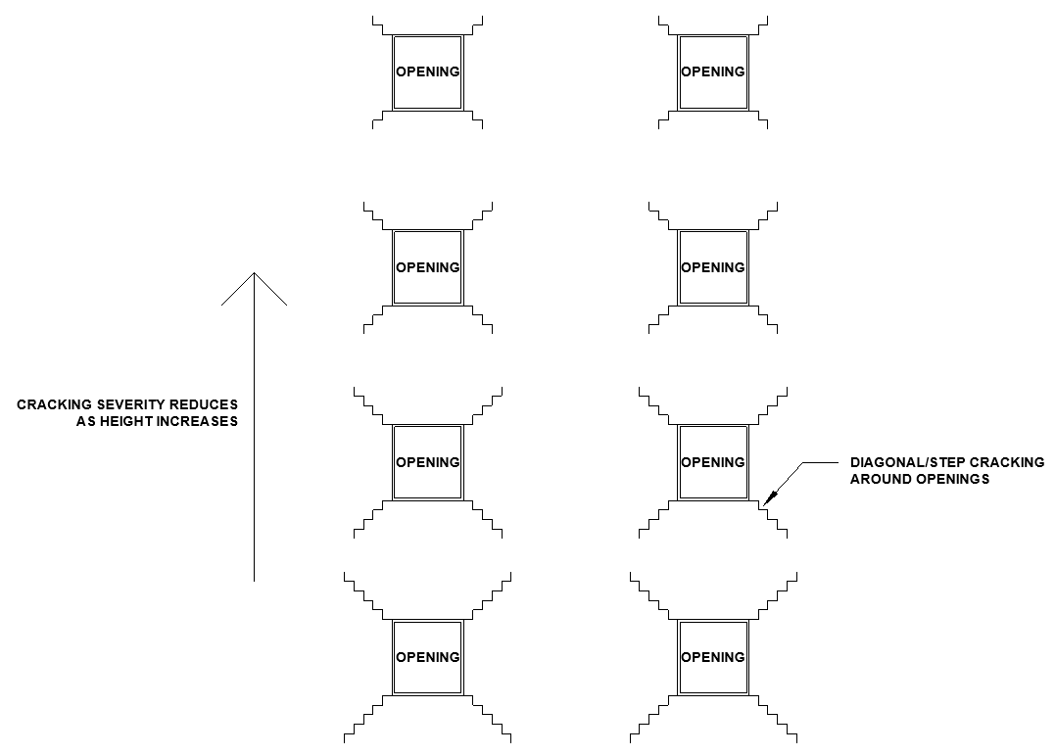

***Figure 4: Typical Crack Patterns in Render Caused by Vibration***

1. Based on our inspection we did not observe any damages that are consistent with vibration or impacts caused from the neighbouring construction site.
2. As such, in our opinion, the observed damage to render predates the construction of the neighbouring building and **is unrelated to the construction works on the neighbouring property or any other insurable event.**
3. Notwithstanding the above, in our opinion, render will continue to delaminate over time due to inherent building issues with the external render.

## Northern Elevation

1. We noted the following damage to the render on the southern façade:

* Cracking and missing render at the slab edge and adjacent to slab edge. **Images 21 – 22**
* Vertical and horizontal cracking in render. **Images 23 – 24**
* Diagonal cracking propagating from the bottom of windows in the middle of the Northern façade. **Images 25 – 26**
* Cracking along vertical expansion joints. **Image 27 – 28**
* Missing render around pipe penetrations. **Image 29 -30**
* Localised missing render on brickwork. **Image 31**
* Blistering and degradation of paint. **Image 32**

1. It has been advised by the building manager that damage to the render on the northern façade of the subject property had worsened since the start of the neighbouring construction.
2. Since there was not a dilapidation survey undertaken prior to the commencement of construction works we are not able to compare the condition of the façade prior to and after the neighbouring construction works.
3. However, considering that the Northern façade is approximately 35m away from the construction site, as shown in ***Figure 5***, it is likely that is was not a requirement due to the northern façade being outside of the “*zone of influence*” which is typically 20-30m away from a construction site and is unlikely to be affected by the construction.

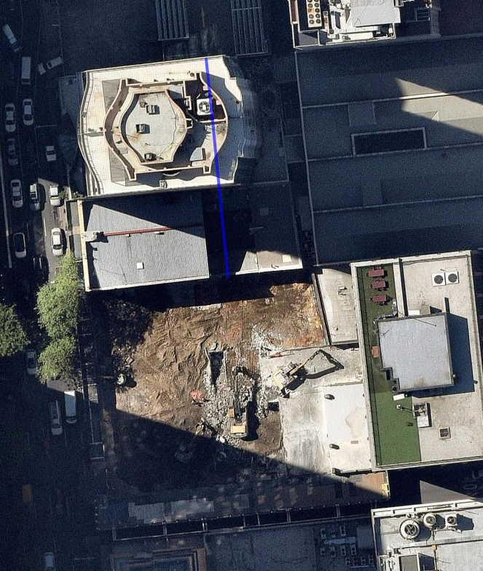

Northern Façade

Construction Site

Approx 35m

***Figure 5: Distance of Northern Façade from the Construction Site***

1. It has been advised by the building manager of the subject property that works have been undertaken since the start of the neighbouring construction to remove delaminated and drummy render on the Northern façade.
2. The majority of the damage to the render was at the slab edge which, in our opinion, is a result of long-term differential movement between the slab and wall resulting in cracking and delamination of render, in representing this effect ***Figure 3*** has been provided above.
3. The observed vertical and horizontal cracking in render, in our opinion, is a result of thermal movement and shrinkage due to insufficient number and spacing of expansion joints in the render.
4. In our opinion, the observed diagonal cracking below windows is a result of long-term differential settlement within the subject building occurring over an extended period of time in years causing cracking to occur below the openings which has consequently caused the render to crack and delaminate.
5. The observed cracking along vertical expansion joints is expected due to thermal movement in the render.
6. Furthermore, in our opinion, the missing render around pipe penetrations is a result of movement in the pipe causing render around the pipe to crack and delaminate.
7. In our opinion, the localised cracking in render is a result of long-term degradation of render causing sections of render to become drummy and delaminate.
8. Finally, in our opinion, the blistering and degradation of paint is a result of water penetrating behind the render from cracks in the render (refer to ***Figure 3*** above) and long-term sun exposure of the render.
9. Based on our inspection we did not observe any damages that are consistent with vibration or impacts caused from the neighbouring construction site, as outlined in ***Figure 4*** above.
10. As such, in our opinion, the observed damage to render predates the construction of the neighbouring building and **is unrelated to the construction works on the neighbouring property or any other insurable event.**
11. Notwithstanding the above, in our opinion, render will continue to delaminate over time due to inherent building issues with the external render.

## Roof

1. It had been advised by the building manager that repairs to cracks and painting to the roof parapet render had already been undertaken within the past 2-3 weeks. **Images 33 – 35**
2. As a result, we are not able to provide an accurate and true comparison of the current and pre-construction condition of the roof parapet based on the photos provided in the MAJ dilapidation report as no cracks were visible.
3. To this end, we are unable to categorically determine if any damages has been sustained to the roof parapet due to the repairs already undertaken at the time of the inspection, however, considering that external render damage is considered not to be attributed to the neighbouring construction, in our opinion, **the condition of the roof parapet would have remained unchanged from the condition prior to the neighbouring construction.**

## Stormwater Riser (Level 16)

1. It had been advised by the building manager that a stormwater pipe had broken on level 16 during the construction on the neighbouring property. **Image 36**
2. In general, vibration caused from construction would cause issues to arise on lower levels due to higher energy within the lower levels.
3. In saying this it is unlikely that vibration would cause an isolated pipe approximately mid height on the structure to break without affecting pipes on lower levels.
4. To this end, considering this is an isolated event located only on level 16, in our opinion, the broken stormwater pipe **is attributed to inherent building defects that predate the neighbouring construction and is unrelated to the neighbouring construction or any other insurable event.**

## Render within Units

1. It has been advised by the building manager that cracking has occurred within a number of units which has been claimed to be caused by the neighbouring construction.
2. It is understood that the building manager is putting together a report of cracking in units that is reported as being a result of the neighbouring construction.
3. However, the original dilapidation report produced by MAJ did not record the condition of any units within the subject property.
4. At the time of the inspection we only inspected Unit 17 & Unit 114.

### Unit 17

1. We noted a vertical crack approximately 1mm in width within the render of the loungeroom wall for the entire height of the wall. **Images 37 – 38**
2. It has been advised by the owner of Unit 17 that they moved into the subject unit approximately three (3) years ago and that the crack was existing at time of occupancy, however it is claimed that the crack has increased in size since occupying the subject unit.
3. In our opinion, the observed vertical crack is consistent with thermal movement and shrinkage within the render causing the observed crack and is a result of the omission of movement joints within the render.
4. Furthermore, cracks widen over seasonal changes, and in our opinion, is the cause of the visual changes to the width as claimed by the owner of the unit.
5. We also noted diagonal cracking propagating from the window within the render. **Image 39**
6. In our opinion, the observed cracking is a result of long-term differential thermal movement within the brickwork under the opening and adjacent to the opening.
7. Should an expansion joint have been placed at the joint between the brickwork below and adjacent to the window than, in our opinion, the observed cracking would not have occurred.
8. In our opinion, the observed render cracking within Unit 17 **is attributed to inherent building defects that predate the neighbouring construction and is unrelated to the neighbouring construction or any other insurable event.**

### Unit 114 – Balcony

1. We noted the following damage to the render on the Unit 114 Balcony:

* Missing render & cracking at the slab edge and adjacent to slab edge. **Images 40 – 41**
* Vertical and horizontal cracking in render. **Images 42**
* Localised removed drummy render. **Image 43 – 44**
* Concrete cancer & exposed reinforcing. **Image 45**
* Cracking along vertical expansion joints. **Image 46**
* Vertical cracking in balcony edge upturn render. **Image 47 – 49**
* Blistering and degradation of paint. **Images 50 – 51**

1. It has been advised by the building manager of the subject property that works have been undertaken since the start of the neighbouring construction to repair drummy render. **Images 52 – 54**
2. Damage to the render at the slab edge, in our opinion, is a result of long-term differential movement between the slab and wall resulting in cracking and delamination of render, in representing this effect ***Figure 3*** has been provided above.
3. The observed vertical and horizontal cracking in render, in our opinion, is a result of thermal movement and shrinkage due to insufficient number and spacing of expansion joints in the render.
4. In our opinion, the localised removal of drummy render is a result of long-term degradation of render causing sections of render to become drummy and delaminate.
5. Furthermore, in our opinion, the observed concrete cancer and exposed reinforced is a result of insufficient cover to the reinforcement at the time of construction and is an inherent building defect, which has also subsequently caused render to crack and delaminate.
6. The observed cracking along vertical expansion joints is expected due to thermal movement in the render.
7. Vertical cracking observed on the balcony upturn render is, in our opinion, a result of inadequate spacings of expansion joints within the render to allow for thermal movement and shrinkage which has consequently resulted in the observed render cracks.
8. Finally, in our opinion, the blistering and degradation of paint is a result water penetrating behind the render from cracks in the render (refer to ***Figure 3***) and long-term sun exposure of the render.
9. Based on our inspection we did not observe any damages that are consistent with vibration or impacts caused from the neighbouring construction site.
10. To this end, in our opinion, the observed damages to render within the balcony area of Unit 114 **is attributed to inherent building defects that predate the neighbouring construction and is unrelated to the neighbouring construction or any other insurable event.**

Notwithstanding the above, in our opinion, render will continue to delaminate over time due to inherent building issues with the external render.

**Discussion**

NA

**Conclusion**

During our inspection, the building manager of the subject property expressed concerns over a number of issues that are claimed to be as a result of the construction of the neighbouring property.

In providing a summary of the observed damages and the causes of the damages we have provided the table below.

|  |  |  |  |
| --- | --- | --- | --- |
| **Location** | **Damage** | **Cause of Damage** | **Any Damage Related to Neighbouring Construction Works?** |
| Basement | Water Ingress from Wall and Slab | Build-up of ground water behind the wall causing water to penetrate through the wall and slab above due to inadequate or blocked subsoil drainage, unrelated to the neighbouring construction. | No |
| Southern Elevation Façade | Cracking and missing render at the slab edge and adjacent to slab edge | Long-term differential movement between the slab and wall resulting in cracking and delamination of render, unrelated to the neighbouring construction. | No |
| Vertical and horizontal cracking in render | Thermal movement and shrinkage due to insufficient number and spacing of expansion joints in the render, inherent building defect unrelated to the neighbouring construction. | No |
| Diagonal cracking propagating from the bottom of windows in the middle of the Southern façade | Long-term differential settlement within the subject building causing cracking to occur below the openings which has consequently caused the render to crack and delaminate, unrelated to the neighbouring construction. | No |
| Cracking along vertical expansion joints | Cracking along vertical expansion joints is expected due to thermal movement and shrinkage in the render, unrelated to the neighbouring construction. | No |
| Missing render around pipe penetrations | Movement in the pipe causing render around the pipe to crack and delaminate, unrelated to the neighbouring construction. | No |
| Localised missing render on brickwork | Long-term degradation of render causing sections of render to become drummy and delaminate, unrelated to the neighbouring construction. | No |
| Blistering and degradation of paint | Water penetrating behind the render from cracks in the render and long-term sun exposure of the render, unrelated to the neighbouring construction. | No |
| Northern Elevation Façade | Cracking and missing render at the slab edge and adjacent to slab edge | Long-term differential movement between the slab and wall resulting in cracking and delamination of render, unrelated to the neighbouring construction. | No |
| Vertical and horizontal cracking in render | Thermal movement and shrinkage due to insufficient number and spacing of expansion joints in the render, inherent building defect unrelated to the neighbouring construction. | No |
| Diagonal cracking propagating from the bottom of windows in the middle of the Northern façade | Long-term differential settlement within the subject building causing cracking to occur below the openings which has consequently caused the render to crack and delaminate, unrelated to the neighbouring construction. | No |
| Cracking along vertical expansion joints | Cracking along vertical expansion joints is expected due to thermal movement and shrinkage in the render, unrelated to the neighbouring construction. | No |
| Missing render around pipe penetrations | Movement in the pipe causing render around the pipe to crack and delaminate, unrelated to the neighbouring construction. | No |
| Localised missing render on brickwork | Long-term degradation of render causing sections of render to become drummy and delaminate, unrelated to the neighbouring construction. | No |
| Blistering and degradation of paint | Water penetrating behind the render from cracks in the render and long-term sun exposure of the render, unrelated to the neighbouring construction. | No |
| Roof | Cracking in Render | Damaged render had been repaired and painted at the time of our inspection, however considering no damage to the render relating to the neighbouring construction was observed on the facades, in our opinion, the roof would have not sustained damage. | No |
| Level 16 Stormwater Riser | Broken Stormwater Pipe during Construction | Isolated incident on Level 16 due to movement inherent building defects, unrelated to the neighbouring construction. | No |
| Unit 17 | Cracking in Loungeroom Wall Render | The cracking observed is a result of the omission of movement joints within the render to allow for thermal movement and shrink in the render.  It has been advised that the crack predates the construction, however has increased in width during the construction process, however seasonal changes will result in cracks widening, which in our opinion is the cause of the claimed increase in crack width and is unrelated to the neighbouring construction. | No |
| Diagonal Cracking Below Window | Long-term differential thermal movement within the brickwork under the opening and adjacent to the opening causing the render to crack due to insufficient expansion joints, unrelated to the neighbouring construction. | No |
| Unit 114 (Balcony) | Cracking and missing render at the slab edge and adjacent to slab edge | Long-term differential movement between the slab and wall resulting in cracking and delamination of render, unrelated to the neighbouring construction. | No |
| Vertical and horizontal cracking in render | Cracking along vertical expansion joints is expected due to thermal movement and shrinkage in the render, unrelated to the neighbouring construction. | No |
| Localised removal of drummy render | Long-term degradation of render causing sections of render to become drummy and delaminate, unrelated to the neighbouring construction. | No |
| Concrete cancer & exposed reinforcing | insufficient cover to the reinforcement at the time of construction which is an inherent building defect, which has also subsequently caused render to delaminate, unrelated to the neighbouring construction. | No |
| Cracking along vertical expansion joints | Cracking along vertical expansion joints is expected due to thermal movement and shrinkage in the render, unrelated to the neighbouring construction. | No |
| Vertical cracking in balcony edge upturn render | Inadequate spacings of expansion joints within the render to allow for thermal movement which has resulted in the observed cracking, unrelated to the neighbouring construction. | No |
| Blistering and degradation of paint | Water penetrating behind the render from cracks in the render and long-term sun exposure of the render, unrelated to the neighbouring construction. | No |

Generally, damages caused by vibration from a neighbouring building site will produce crack patterns where cracking is more severe at lower levels and less severe as height increases.

However, we did not observe any damages that are consistent with that caused by vibration from a construction site.

Furthermore, render has been removed from the facades of the subject building and a true and accurate comparison cannot be made with the pre-construction condition as outlined in the MAJ dilapidation report.

To this end, **we were not able to identify any damages to the subject property that were a result of the neighbouring construction or any other insurable event.**